Student Code Number:___________________

**Ph.D. Qualifying Exam**

**Dynamic Systems and Control**

**Fall 2017**

Professor George Zhu

Professor Michael Lavagnino

Department of Mechanical Engineering

Michigan State University

Open Book (one book allowed)

Answer All Questions

All Questions Weight Equally

Network Devises Are Not Allowed

All Work Should Be Shown For Full Credit

Time: 3.0 hours

Consider the following unit negative feedback system



1. Find the closed-loop transfer function $G_{CL}\left(s\right)=\frac{Y(s)}{U(s)}$.
2. Calculate ramp-error constant  as a function of *a* > 0 and find “*a*” such that the steady-state error ( $e_{ss})$ with respect to unit ramp input is 0.5.
3. Using “*a*” found in b), calculate the corresponding closed-loop system damping coefficient ($ζ$) and natural frequency ($ω_{n})$.
4. Find the closed-loop system 2% settling time $t_{s}(2\%)$ and percentage of overshoot ($σ)$.
5. For the closed-loop system shown below with the corresponding Root Locus, when $K=10$ the closed-system is marginally stable. Find the unique transfer function $G\left(s\right).$



1. A researcher determines the following non-linear differential equation model of soft tissue strain $ϵ$ versus stress values, σ (MPa) during loading. $$\dot{ε}=-8ε-ε^{3}+4ϵσ$$
   1. Find the equilibrium stress value σ0corresponding to a steady strain value of *ε0* = 2.
   2. Find the linearized ordinary differential equation about the equilibrium point, found in a), in terms of $δε=ε-ϵ_{o}$ and $δσ=σ-σ_{0}$.

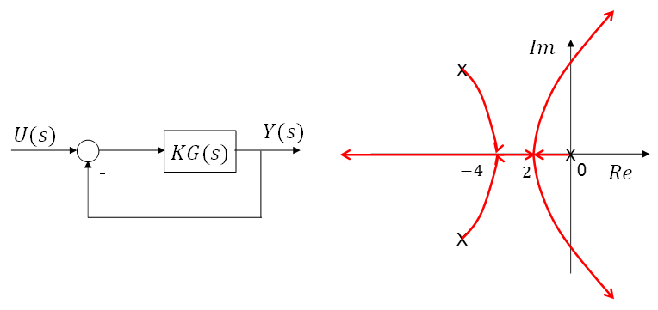4. Consider the negative unit feedback system with a transfer function G(s) as in the figure where K=40.

The bode plot of KG(s) is given as follows: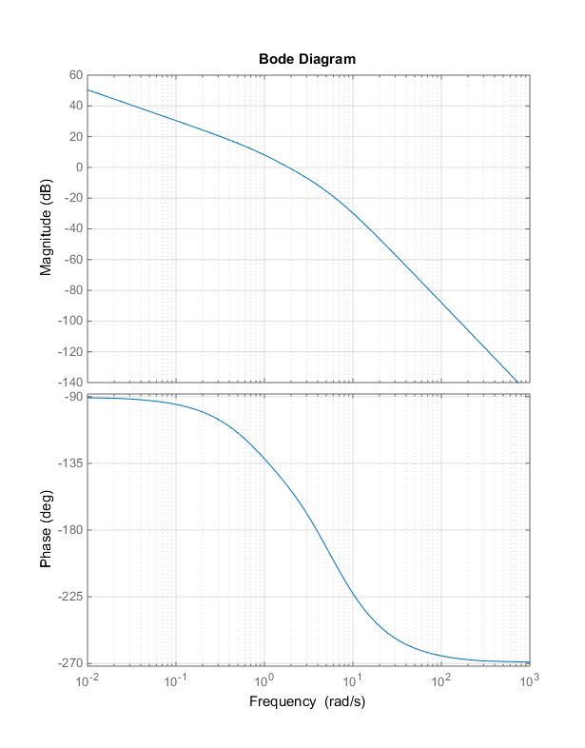

1. Estimate the gain margin (dB) and the phase margin (deg) directly from the bode plot. Justify your answers, i.e., explain how they are obtained from the bode plot.

1. Given that K=40 in the bode plot above, find the maximum integral value of K for which the closed-loop transfer function will remain stable.