Exam Number: ------------------------------

Department of Mechanical Engineering

Michigan State University

Solid and Structural Mechanics
Ph.D. Qualifying Examination

January 2017

Closed Book & Note,
May bring one 8½x11” page with one side of the page only

Network Devises Are Not Allowed
All Work Should Be Shown For Full Credit

Prepared by
Dr. Alejandro Diaz
Dr. Patrick Kwon

- The beam with the stiffness of EI is constrained by three simple supports and loaded with the distributed load of W=120N/m as shown below. (a) Determine the reaction force at each support in the beam. (b) Determine the deflection in the beam at A.

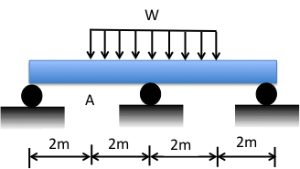

- For a plane stress problem with a plate (E=30GPa, v=0.3 and G=E/2(1+v)), the stresses at A are found to be in the x-y coordinate system shown below. Determine the strain measure to be expected with the strain gauge P and gauge Q.

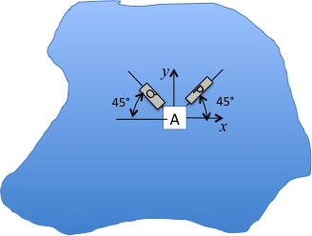

3. The pipe assembly is clamped at the base. Determine the critical location where the assembly is most likely to fail by yielding. Use the Von Mises (equivalent) stress criterion to estimate the safety factor. The material has a yield strength of S=200 MPa and it applies equally in tension and in compression. All dimensions in millimeters.
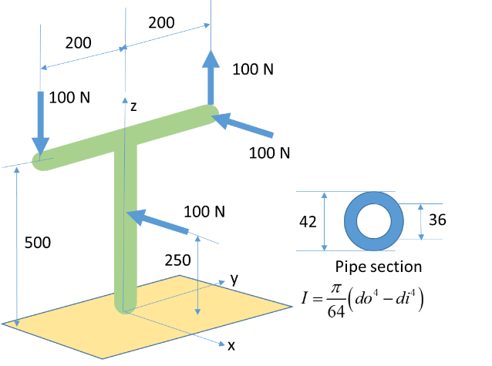

4. Material and cross section areas for all bars in the truss structure are known, and they are the same for all bars. What is the load carried by bar B?
