Solid & Structural Mechanics

Qualifying Examination
2017

Closed Book & Notes,
May bring one 8½x11” page with one side of the page only

1. The beams shown have cross section properties I_{AB} and I_{CD} (I is the moment of inertia in the relevant plane). They are made of the same material. Supports at A and B are simple supports. Beam CD is clamped at C. What are the reactions at A, B and C?

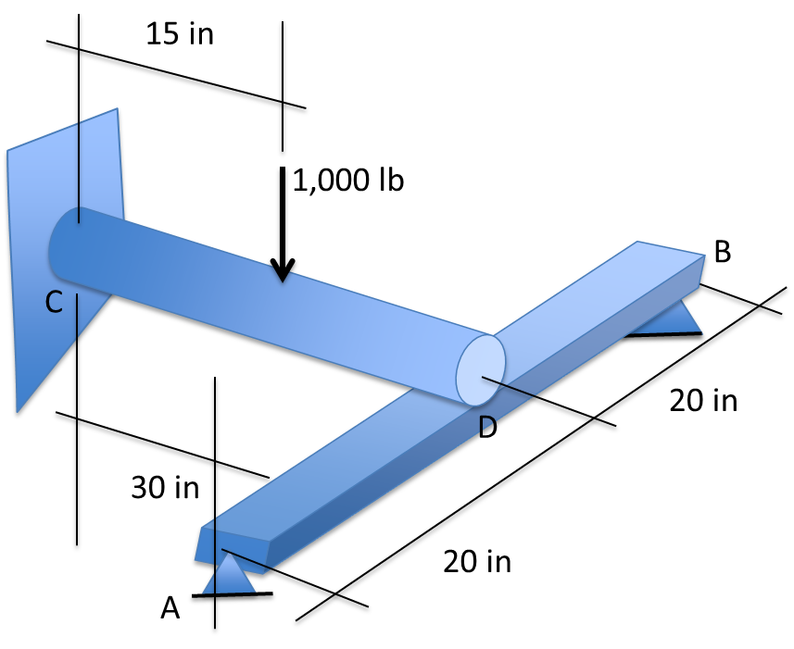
2. The steel pipe has outside diameter d₀ =1.6 in and inside diameter d_{i} =1.4 in. Use the Von Mises (equivalent) stress criterion to estimate the safety factor. The material has a yield strength of S=29 kpsi and it applies equally in tension and in compression. Assume the pipe fails first and ignore shear due to bending.

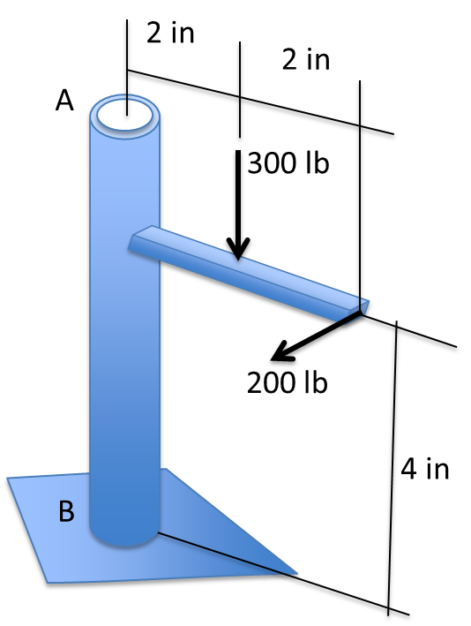

3. The stress state given below is in a plane stress condition. (1) Determine the principal stresses and the maximum in-plane shear stress. (2) Determine the factor of safety given that the yield strength is 100MPa using Tresca criterion. Now the strain gage is put at 45° as shown on the stress element. (3) Determine the reading on the strain gage with E=30GPa and v=0.3.

30MPa
10MPa
10MPa

4. The torsion bar shown below is constructed with two different size round bars with the radius of a bar AB, c_{AB}=6cm and the radius of a bar BC c_{BC}=4cm. (1) Determine the shear stresses in AB and BC due to the torsion loads given below and (2) Given that G=50GPa, determine the angles of twist at C respect to B as well as respect to A.

200Nm

A
B
C

200Nm
1m
1m

