Code No. _

Fluid Mechanics Ph.D Qualifier Exam

Depart ment of l\Iechanical Engineering Michigan State University

January 2019

Directions: Closed book

All problems carry equal weight. In order to receive full credit for a solution, you must show all work clearly.

Exam prepared by Profs. P. Lillehoj and G. Brereton

Stokes flow (also called creeping flow) is a fluid flow at very low Reynolds number ( Re << 1) and can be used to describe the movement of aerosol particles and microorganisms. The drag force FD on an object in a creeping flow is a function of its velocity V , a characteristic length scale L of the object and the fluid viscosity µ.

- Using t he Pi theorem, find the dimensionless parameters t hat describe a relationship for
FD as a function of the independent variables, showing your work.
- Consider a water flee 1 mm in diameter. A 100x full scale model is tested in glycerin ( µ 1.5 kg/m.s) at V 30 cm/s. If the measured drag force on the model is 1N, what is the drag force of the actual '\Nater flee if it moves at 2 cm/s in water (µ = 0.001 kg/m.s)?

A nozzle (3 cm in diameter) connected to a fire hose is held by firefighters with water ( p = 998 kg/m3 ) flowing at 2 m3/min at an angle of 30° to the horizontal. Assume the flow is steady and incompressible.
- Determine the average water exit velocity (in m/s).
- Calculate the horizontal force (in N) exerted on t he firefighters by the water jet. Neglect frictional effects and minor losses.

The differential .T-moment um equation for steady, fully developed, incompressible flow of a Newtonian fluid in a two-dimensional Cartesian inertial frame is
iap 02 11
0 = --->:. + !T + v 5:i 0
p ux uy

where f r is the body force in the ;T-direction. Consider the problem of a liquid layer of thickness h flowing down a long flat vertical surface under gravity. The outside of the sheet is exposed to air at atmospheric pressure.
- \Vhat are t he boundary conditions on u?
- Find an expression for u as a function of y .
- At what value of y is u equal to its average value?

/ r
/

\¥ater flows up the inclined (at 30° ) pipe as shown. If the volumetric flow rate is 0.02 111 /s, determine t he height h to which the water will rise in the pitot tube.
3
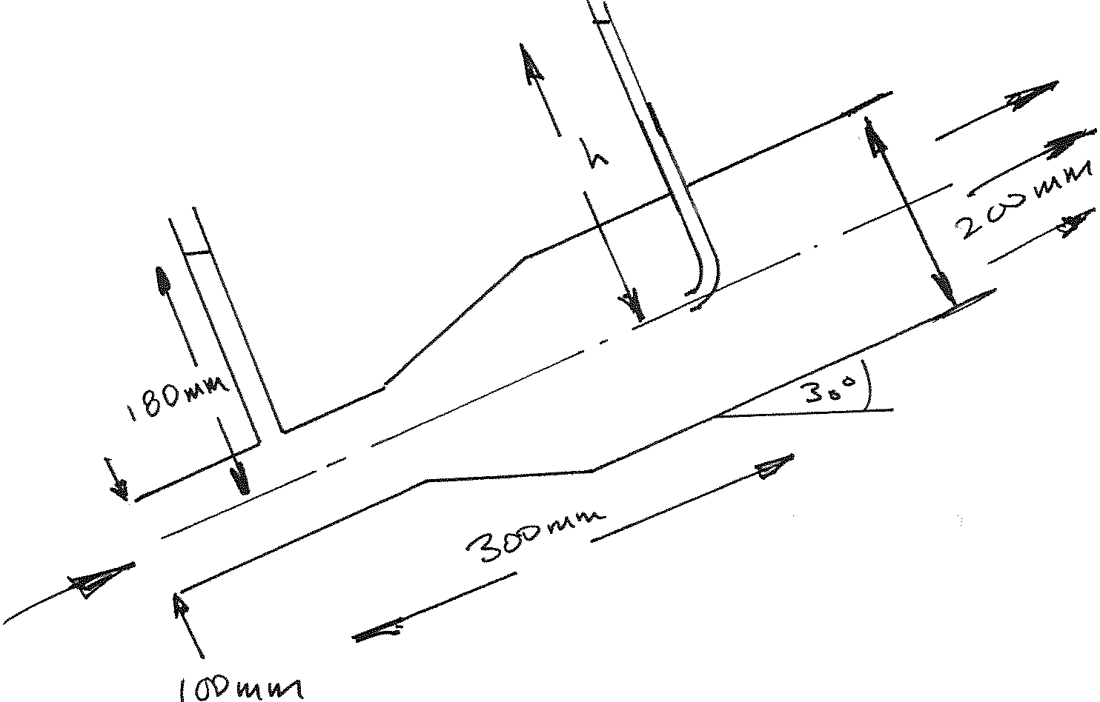

The container shown is filled with water and kerosine to the depths given. What mass Ai
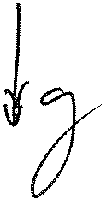
is required to keep the gate in place? Assume Pwatcr 1000 kg/m3 and Pk cr = 814 kg/m3 .

