**Code Number :**..............

**HEAT TRANSFER QUALIFYING EXAM**

January 2017

**One book allowed (closed notes)**

Answer all questions

All questions have equal weight

TIME: 3.0 hrs

Prepared by Profs. N. Wright and J. Yeom

**Problem 1.** A pin fin of length 2*L* and diameter *d* generates heat at a uniform volumetric rate *q’’’*. A half of the fin is insulated while the other half exchanges heat by convection with the heat transfer coefficient *h* and the ambient temperature *T*∞. Both ends of the fin are insulated. The thermal conductivity of the fin is assumed to be *k*.

1. Use the fin equation and determine the steady state temperature distribution of the fin.
2. Determine the location of the fin for the highest temperature.

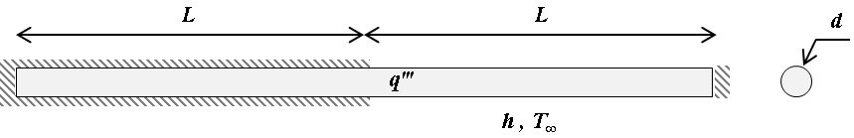

**Problem 2**. An uninsulated plastic duct (*kd* ~ 0.6 W/m-K) of 0.3-m outer diameter and 0.25-m inner diameter carrying chilled air at 0.05 kg/s is exposed to cool down a room. The room air is at 27°C, and the outer surface of the duct is subject to natural convection condition. If chilled air enters a 15-m long duct at 7°C, what is its exit temperature? For simplicity, the properties of chilled air can be evaluated at 300K.

**Problem 3.** For the figure shown, find the view factor F2→4.



**Problem 4.** The trailer of truck contains saturated liquid nitrogen at -196 °C. The truck is traveling at 100 km/h and the ambient air temperature is 25 °C. The top of the trailer may be considered a 12 m long, 2 m wide flat plate. Assume that the tank wall is composed of two 1 mm anodized aluminum sheets sandwiching an insulating layer of 5 cm of urethane foam. The heat flux from the sun onto the top surface of the tank is 500 W m-2. Calculate the average steady-state temperature of the top surface of the traile

